Born March 23rd, 1994, from Navarre, Florida. In the pivotal juncture of my life, at the age of 22, I found myself at a crossroads with a stark ultimatum from my father: secure a second job and move out or enlist in the military. A full-time student at North West Florida State College and working part time at Target, the weight of responsibility pressed upon me like a burden.
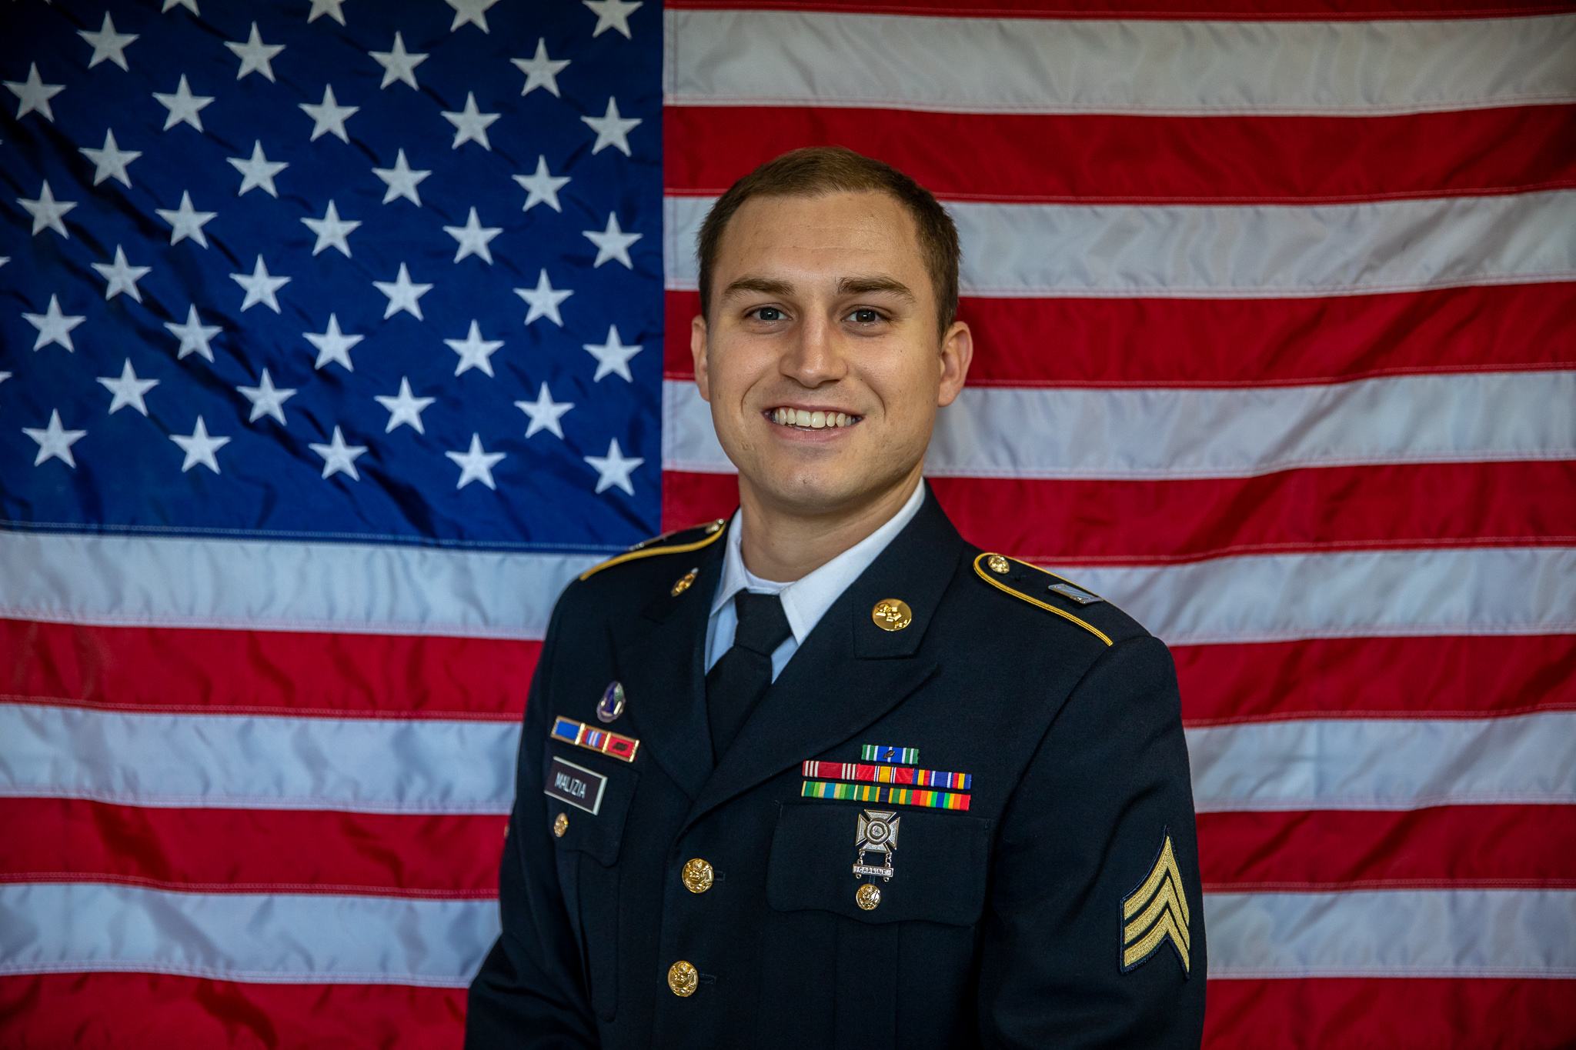

Insert DA Photo
The following day, as I sat in the campus café, grappling with a Bacon Lettuce and Tomato sandwich, my father's words echoed in my mind. It was then that fate intervened in the form of two Army recruiters who entered the scene. Seizing the moment, I engaged in a conversation with them, sensing an opportunity in the air. This marked the beginning of my journey as a Chemical Warfare Soldier in the United States Army.
As a guardian against chemical warfare attacks, my mission was clear – to safeguard my fellow soldiers and ensure their readiness for battle. The decision to enlist stemmed from a desire for financial stability, healthcare, and the prospect of having my college expenses covered. Prior to my military service, I had navigated through a series of low-paying jobs, drowning in medical debt and student loans.
Joining the Army not only liberated me from the shackles of debt but also paved the way for my educational pursuits through the Army's tuition assistance program. Over the course of my six-year tenure, each passing year has brought forth new opportunities for growth. Starting as a private with a modest income of $1,500 a month, I have steadily climbed the ranks and now earn more than $60,000 a year.
The Army has not only provided financial stability but has also been a passport to exploration. From my initial assignment in North Carolina to my most recent residence in Germany, I have traversed the globe, experiencing diverse cultures, all funded by the Army. Today, I am not just a soldier; I am a testament to the transformative power of military service, shaping my present and securing my future.

